MODUL 3: SISI CUSTOMER (Katalog & Form Checkout Pesanan)
1. Buka file app/Http/Controllers/OrderController.php
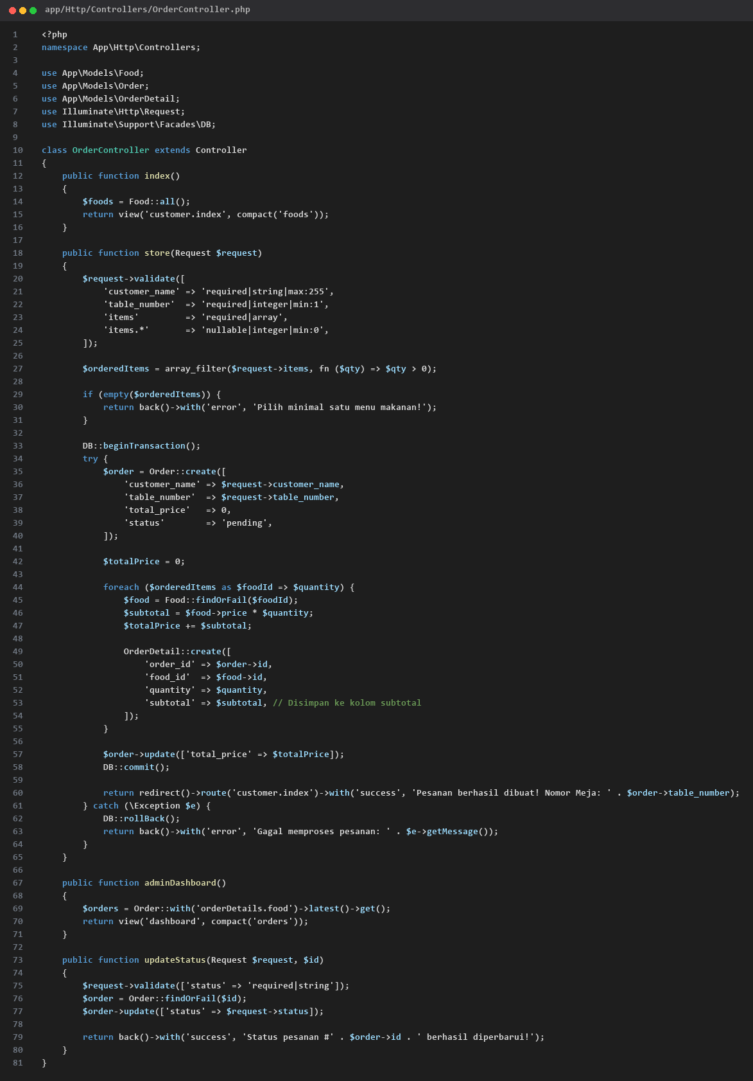
app/Http/Controllers/OrderController.php
2. Buat Tampilan Menu Pelanggan (resources/views/customer/index.blade.php)
Buat file resources/views/customer/index.blade.php. Modal konfirmasi ditaruh di dalam form dan tombol menggunakan type='submit' asli:
<!DOCTYPE html>
<html lang="id">
<head>
<meta charset="UTF-8">
<meta name="viewport" content="width=device-width, initial-scale=1.0">
<title>Menu Restoran</title>
<script src="https://cdn.tailwindcss.com"></script>
</head>
<body class="bg-gray-100 p-6 font-sans">
<div class="max-w-5xl mx-auto">
<div class="text-center mb-6">
<h1 class="text-3xl font-bold text-gray-800">Menu Restoran</h1>
<p class="text-gray-500 text-sm mt-1">Pilih menu makanan dan masukkan nomor meja Anda</p>
</div>
<!-- NOTIFIKASI SUCCESS / ERROR / VALIDASI -->
@if(session('success'))
<div class="bg-green-100 border border-green-400 text-green-700 px-4 py-3 rounded-xl mb-6 text-center font-semibold">{{ session('success') }}</div>
@endif
@if(session('error'))
<div class="bg-red-100 border border-red-400 text-red-700 px-4 py-3 rounded-xl mb-6 text-center font-semibold">{{ session('error') }}</div>
@endif
@if($errors->any())
<div class="bg-red-100 border border-red-400 text-red-700 px-4 py-3 rounded-xl mb-6 font-semibold">
<ul class="list-disc list-inside">
@foreach($errors->all() as $error)
<li>{{ $error }}</li>
@endforeach
</ul>
</div>
@endif
<!-- FILTER KATEGORI (JAVASCRIPT) -->
<div class="flex flex-wrap justify-center gap-3 mb-8">
<button type="button" onclick="filterCategory('all', this)" class="btn-category px-5 py-2 rounded-full font-semibold text-sm transition bg-blue-600 text-white shadow-md">Semua Menu</button>
<button type="button" onclick="filterCategory('Makanan', this)" class="btn-category px-5 py-2 rounded-full font-semibold text-sm transition bg-white text-gray-600 hover:bg-gray-200 border">Makanan</button>
<button type="button" onclick="filterCategory('Minuman', this)" class="btn-category px-5 py-2 rounded-full font-semibold text-sm transition bg-white text-gray-600 hover:bg-gray-200 border">Minuman</button>
<button type="button" onclick="filterCategory('Cemilan', this)" class="btn-category px-5 py-2 rounded-full font-semibold text-sm transition bg-white text-gray-600 hover:bg-gray-200 border">Cemilan</button>
</div>
<form id="orderForm" action="{{ route('customer.checkout') }}" method="POST">
@csrf
<!-- 1. Informasi Pemesan -->
<div class="bg-white p-6 rounded-xl shadow-sm border mb-6">
<h2 class="text-lg font-bold text-gray-700 mb-4 pb-2 border-b">1. Informasi Pemesan</h2>
<div class="grid grid-cols-1 md:grid-cols-2 gap-4">
<div>
<label class="block text-sm font-semibold text-gray-600 mb-1">Nama Lengkap</label>
<input type="text" id="customer_name" name="customer_name" required placeholder="Masukkan nama pemesan" class="w-full border rounded-lg px-4 py-2 focus:ring-2 focus:ring-blue-500 outline-none">
</div>
<div>
<label class="block text-sm font-semibold text-gray-600 mb-1">Nomor Meja</label>
<input type="number" id="table_number" name="table_number" required placeholder="Contoh: 05" class="w-full border rounded-lg px-4 py-2 focus:ring-2 focus:ring-blue-500 outline-none">
</div>
</div>
</div>
<!-- 2. Pilih Menu -->
<h2 class="text-lg font-bold text-gray-700 mb-4">2. Pilih Menu</h2>
<div class="grid grid-cols-1 md:grid-cols-3 gap-6">
@foreach($foods as $food)
<div class="food-card bg-white rounded-xl shadow-sm border overflow-hidden flex flex-col justify-between" data-category="{{ $food->category ?? 'Makanan' }}">
<div>
@if($food->image)
<img src="{{ asset('storage/' . $food->image) }}" alt="{{ $food->name }}" class="w-full h-40 object-cover">
@else
<div class="bg-gray-200 h-40 flex items-center justify-center text-gray-400 font-medium">Tanpa Gambar</div>
@endif
<div class="p-4">
<div class="flex justify-between items-center mb-2">
<span class="text-xs bg-blue-100 text-blue-700 font-semibold px-2.5 py-0.5 rounded">{{ $food->category ?? 'Makanan' }}</span>
<span class="font-bold text-green-600">Rp {{ number_format($food->price) }}</span>
</div>
<h3 class="font-bold text-gray-800 text-lg item-name">{{ $food->name }}</h3>
<p class="text-xs text-gray-500 mt-1 line-clamp-2">{{ $food->description }}</p>
</div>
</div>
<div class="p-4 bg-gray-50 border-t">
<label class="block text-xs font-semibold text-gray-500 mb-1">Jumlah Porsi</label>
<input type="number" name="items[{{ $food->id }}]" min="0" value="0" data-name="{{ $food->name }}" data-price="{{ $food->price }}" class="item-qty w-full border rounded-lg px-3 py-1.5 text-center font-bold text-gray-700 focus:ring-2 focus:ring-blue-500 outline-none">
</div>
</div>
@endforeach
</div>
<div class="mt-8 text-right">
<button type="button" onclick="showConfirmationModal()" class="bg-blue-600 hover:bg-blue-700 text-white font-bold px-8 py-3 rounded-xl shadow-md transition">Pesan Sekarang</button>
</div>
<!-- MODAL KONFIRMASI PESANAN (DI DALAM FORM) -->
<div id="confirmModal" class="fixed inset-0 bg-black/50 hidden items-center justify-center z-50 p-4">
<div class="bg-white rounded-2xl max-w-md w-full p-6 shadow-2xl transform transition-all">
<h3 class="text-xl font-bold text-gray-800 border-b pb-3 mb-4">Konfirmasi Pesanan</h3>
<div class="space-y-2 text-sm text-gray-600 mb-4">
<div class="flex justify-between"><span class="font-semibold">Nama:</span> <span id="modalName" class="text-gray-900 font-bold"></span></div>
<div class="flex justify-between"><span class="font-semibold">No. Meja:</span> <span id="modalTable" class="text-gray-900 font-bold"></span></div>
</div>
<div class="border-t border-b py-3 mb-4 max-h-48 overflow-y-auto">
<p class="font-semibold text-xs text-gray-400 uppercase mb-2">Rincian Item</p>
<ul id="modalItemList" class="space-y-2 text-sm"></ul>
</div>
<div class="flex justify-between items-center text-lg font-bold text-gray-800 mb-6">
<span>Total Pembayaran:</span>
<span id="modalTotalPrice" class="text-green-600 text-xl">Rp 0</span>
</div>
<div class="flex gap-3">
<button type="button" onclick="closeConfirmationModal()" class="w-1/2 bg-gray-200 hover:bg-gray-300 text-gray-700 font-semibold py-2.5 rounded-xl transition">Batal</button>
<button type="submit" class="w-1/2 bg-green-600 hover:bg-green-700 text-white font-bold py-2.5 rounded-xl shadow transition">Ya, Kirim Pesanan</button>
</div>
</div>
</div>
</form>
</div>
<script>
function filterCategory(category, element) {
document.querySelectorAll('.btn-category').forEach(btn => {
btn.className = "btn-category px-5 py-2 rounded-full font-semibold text-sm transition bg-white text-gray-600 hover:bg-gray-200 border";
});
element.className = "btn-category px-5 py-2 rounded-full font-semibold text-sm transition bg-blue-600 text-white shadow-md";
const cards = document.querySelectorAll('.food-card');
cards.forEach(card => {
const cardCategory = card.getAttribute('data-category');
card.style.display = (category === 'all' || cardCategory === category) ? 'flex' : 'none';
});
}
function showConfirmationModal() {
const name = document.getElementById('customer_name').value.trim();
const table = document.getElementById('table_number').value.trim();
if (!name || !table) {
alert('Silakan isi Nama Lengkap dan Nomor Meja terlebih dahulu!');
return;
}
const items = document.querySelectorAll('.item-qty');
let itemListHtml = '';
let grandTotal = 0;
let hasOrder = false;
items.forEach(input => {
const qty = parseInt(input.value) || 0;
if (qty > 0) {
hasOrder = true;
const itemName = input.getAttribute('data-name');
const price = parseFloat(input.getAttribute('data-price'));
const subtotal = qty * price;
grandTotal += subtotal;
itemListHtml += `<li class="flex justify-between items-center"><div><span class="font-bold text-gray-800">${itemName}</span><span class="text-xs text-gray-500 block">x${qty} @ Rp ${price.toLocaleString('id-ID')}</span></div><span class="font-semibold text-gray-700">Rp ${subtotal.toLocaleString('id-ID')}</span></li>`;
}
});
if (!hasOrder) {
alert('Pilih minimal 1 menu makanan/minuman dengan jumlah lebih dari 0!');
return;
}
document.getElementById('modalName').textContent = name;
document.getElementById('modalTable').textContent = table;
document.getElementById('modalItemList').innerHTML = itemListHtml;
document.getElementById('modalTotalPrice').textContent = 'Rp ' + grandTotal.toLocaleString('id-ID');
const modal = document.getElementById('confirmModal');
modal.classList.remove('hidden');
modal.classList.add('flex');
}
function closeConfirmationModal() {
const modal = document.getElementById('confirmModal');
modal.classList.remove('flex');
modal.classList.add('hidden');
}
</script>
</body>
</html>

3. Update Model OrderDetail (app/Models/OrderDetail.php)
Pastikan file app/Models/OrderDetail.php menggunakan guarded = ['id']:

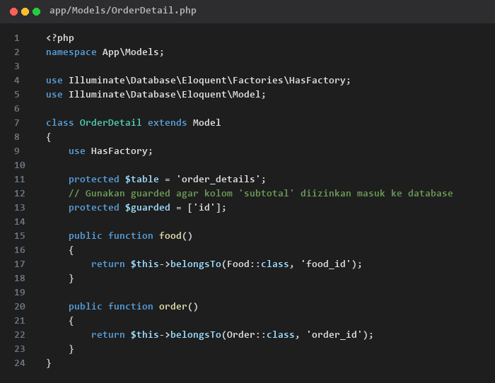
app/Models/OrderDetail.php

